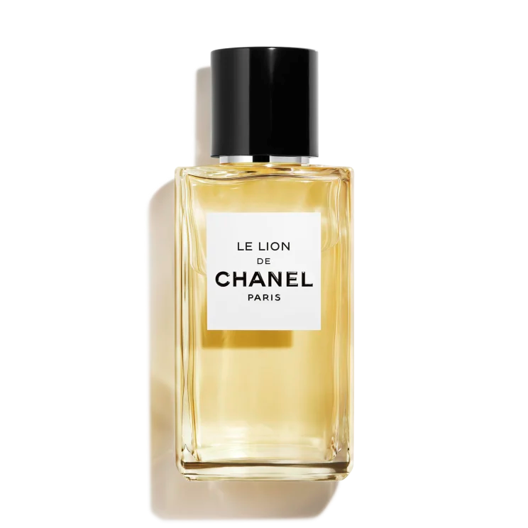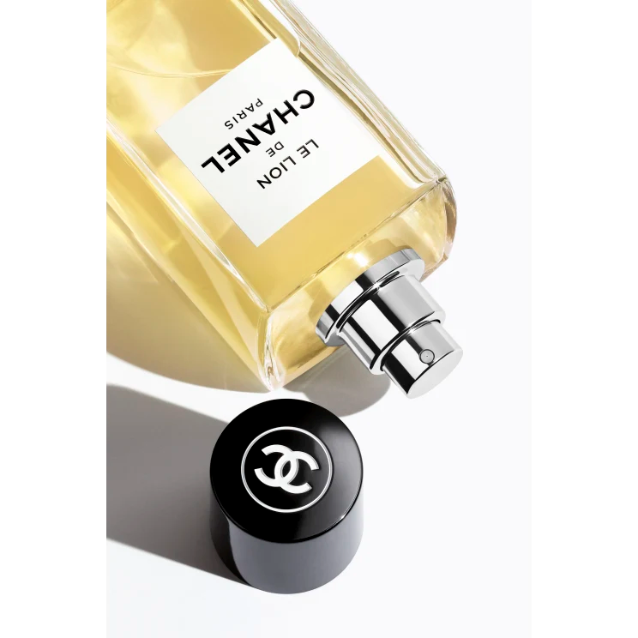

SYCOMORE

$450

Tax Included.

Spray 100 mL

IN STOCK

**Product Details**

Created in 1930 and inspired by the noble spirit of autumn and the childhood of Gabrielle Chanel, the intensely woody scent of SYCOMORE evokes the great outdoors. This pure, majestic fragrance is composed around the smoky scent of vetiver, with notes of cedar and vanilla.